**Routing**

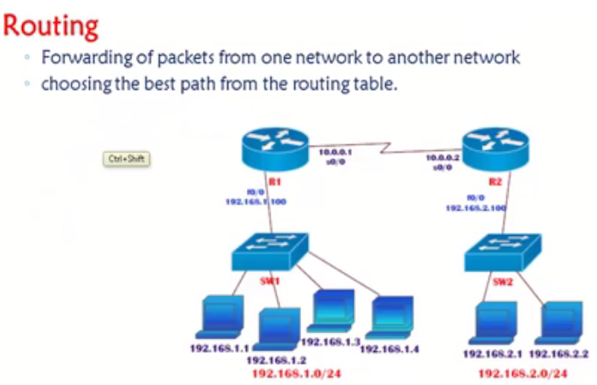

Even though all the devices are connected , Lins are UP and IP address are given still we cannot communicate between 192.168.1. network to 2. Network , Hence we need routing .

Three Types of routing .

Static ,

Default ,

Dynamic .

Difference between Static and Dynamic is , In static administrator will be deciding the best route in dynamic routing protocols will automatically decide the best route .

Default routing generally used in internet connections .

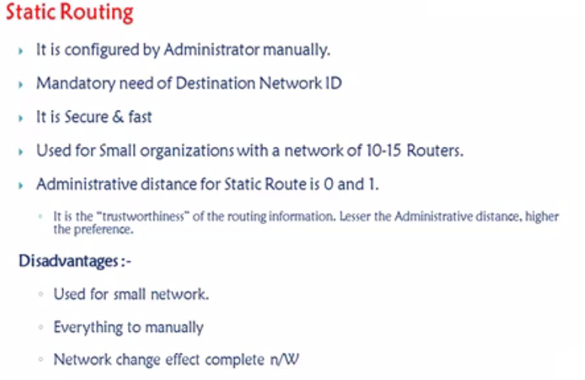

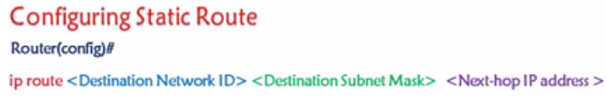

Lab :

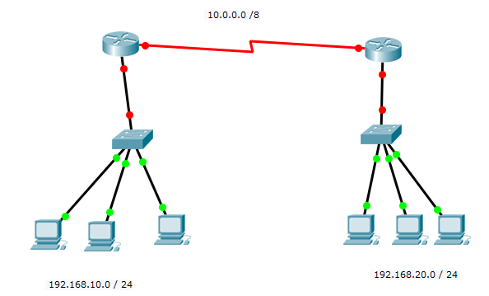

Show IP Route , Ping , Traceroute .

Lab Task : 3 Routers .

**Default Routing**

**Default route** which is also known as the gateway of last resort, is used in forwarding packets whose destination address does not match any route in the routing table .

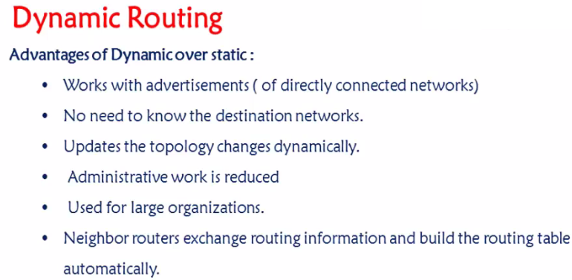

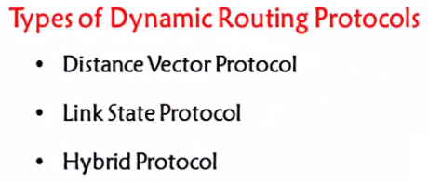



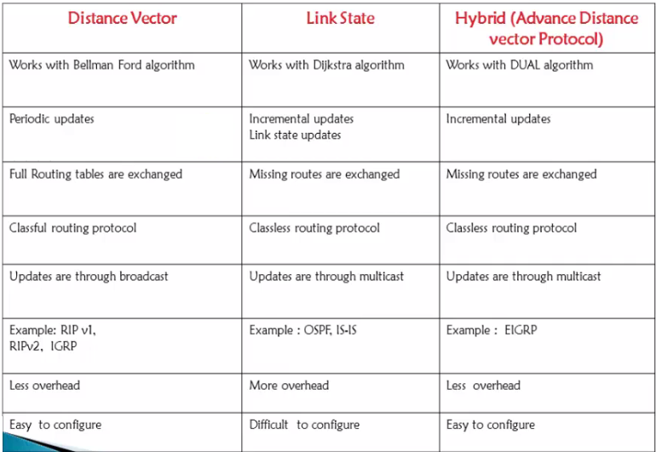



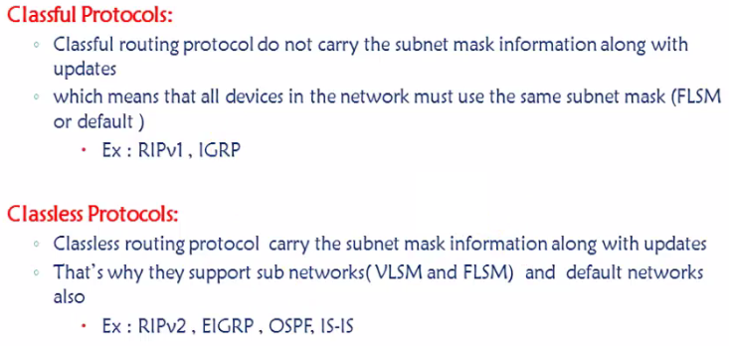

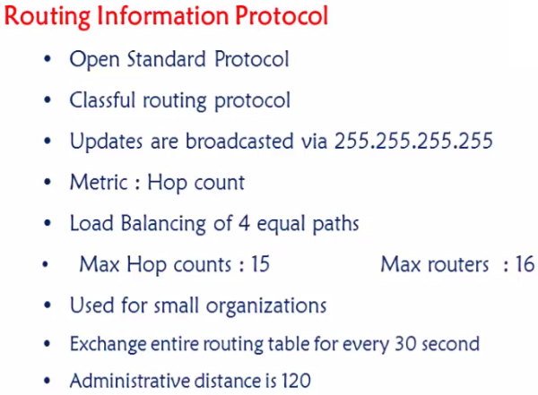



**RIP TIMERS**



**UPDATE timer** = 30Sec. Every router will share its complete routing table with its neighbors once in 30 sec .



**INVALID timer** = 180 [30+150] , 31st sec – If any link goes down none of the Update will be shared to any of its neighbors as they will wait till 180 sec hoping it will come up again .



**FLUSH timer** = 60sec more 240 sec , [180+60] – Removal of entry from Routing table .

**HOLDDOWN timer** = 180sec – In general whenever there is a new update , It will wait for 180 sec for the best route calculation .

In RIP Convergence time is 240sec .

EIGRP = 15sec

OSPF = 40sec

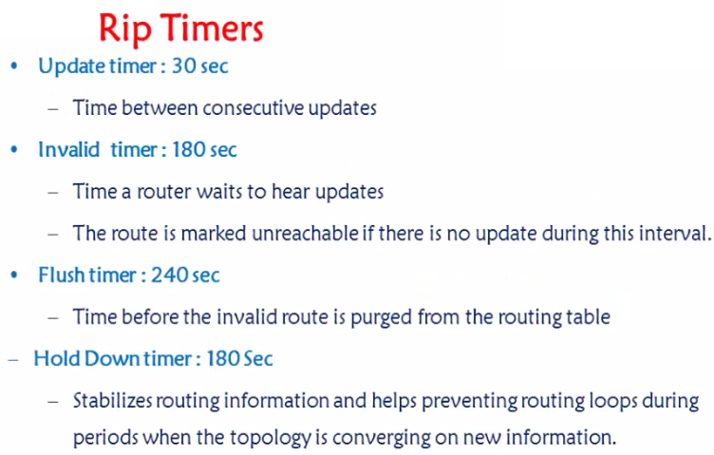

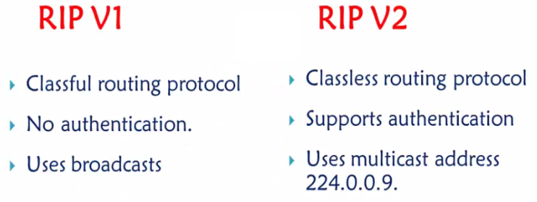



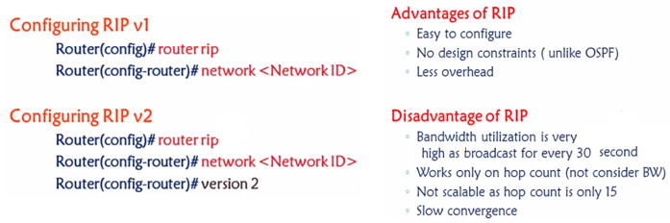



Problem with RIP (Slow Coverage time, Routing loop, Count to Infinity and DV Algorithm)

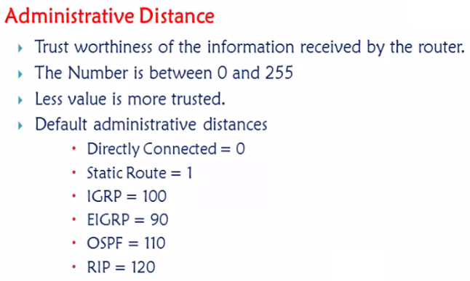

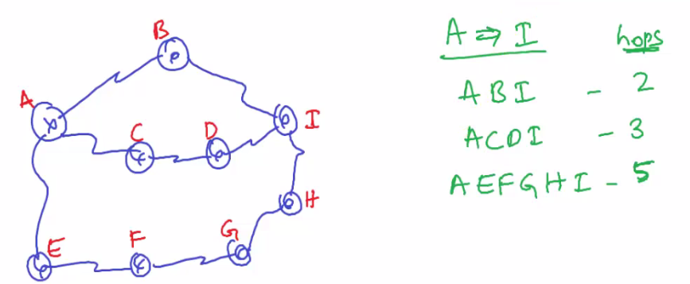

ABI – 100Mbps – EIGRP , ACDI – 80Mbps – RIP , AEFGHI – 10Mbps - Static.

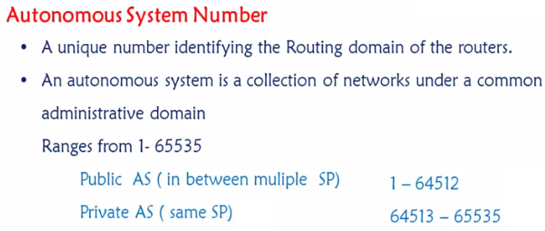

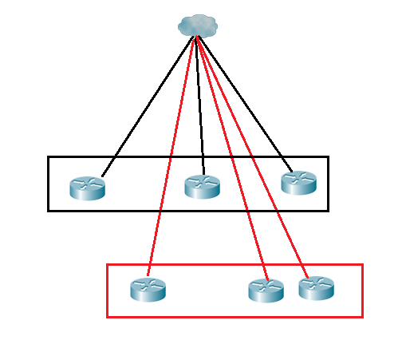

How the SP will differentiate the traffic coming from ABC company and XYZ company – Through Autonomous System number . NOTE : Circuit ID is different .

Private AS system number , Airtel and TATA both can use same AS numbers, no issue as it is used within the SP so no issues . Public AS are used to connect between two different SP .

Similar to public and Private IP address .

Once we now what is Autonomous system number – there are two protocol categories – IBGP and EBGP .

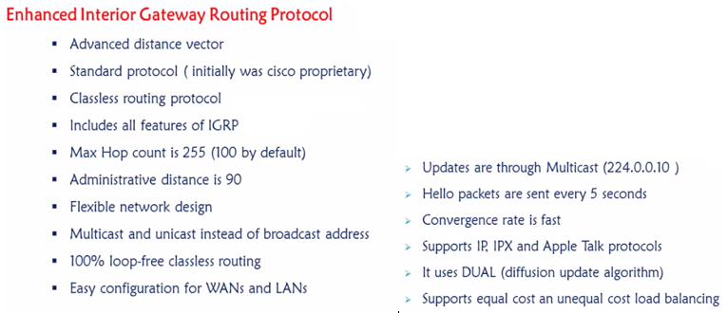

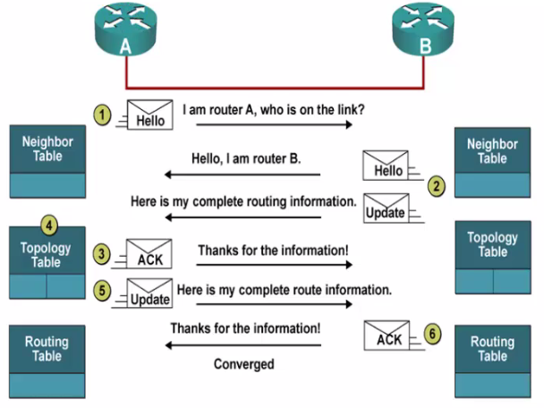

Hello all I am running EIGRP is there anyone else who is running the same and it will send multicast 224.0.0.10 , All EIGRP listen at this address . If any router is not running EIGRP they will not get these hello msgs neither they will understand .

Topology table will have a list of all best routes , This is when it will run DUAL algorithm and find out the best routes .

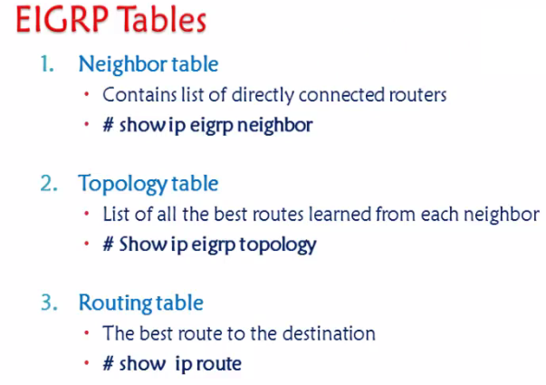

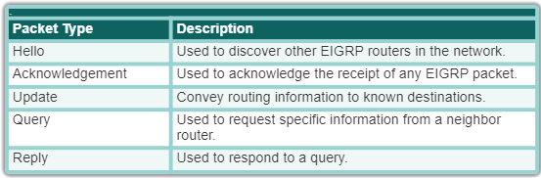

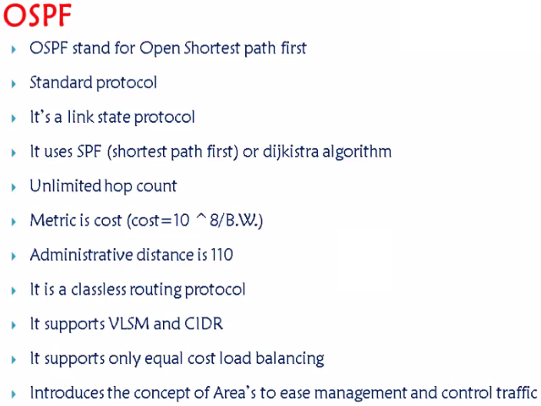

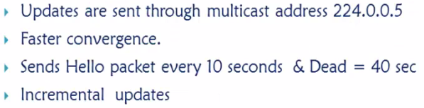

The OSPF timers on a Cisco router depend on what time of interface they are used on.

By default the timers on a broadcast network which include Ethernet, point-to-point and point-to-multipoint are 10 seconds hello and 40 seconds dead. The timers on a non-broadcast network are 30 seconds hello 120 seconds dead.

Incremental updates meaning - Updates will be sent only if there is a change

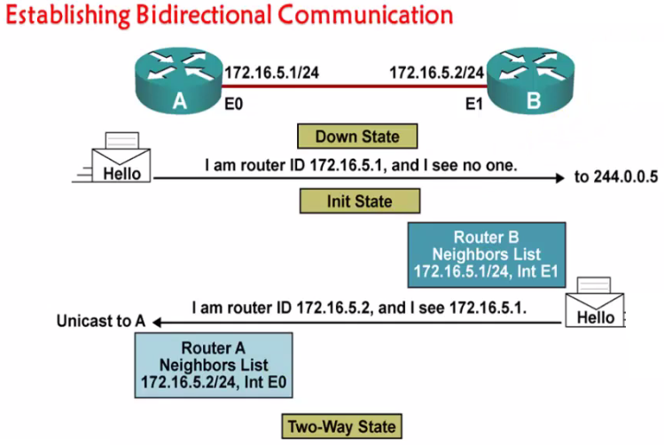

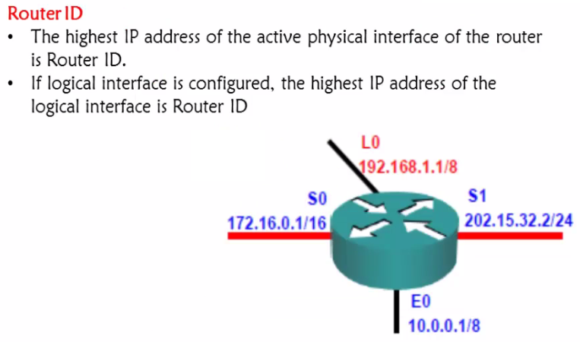

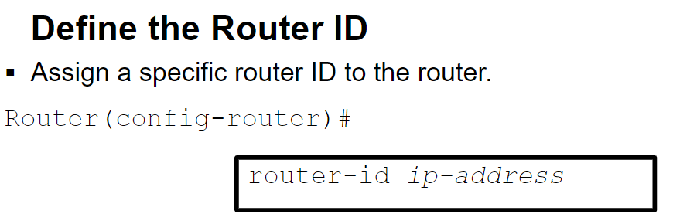

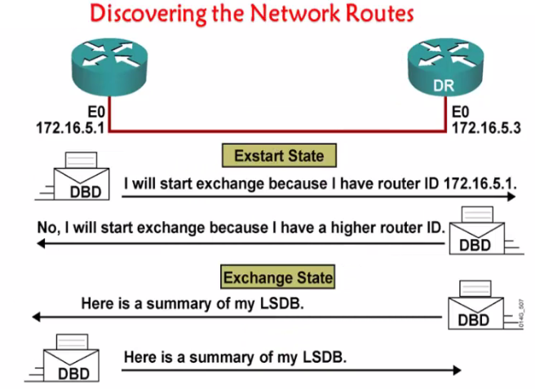

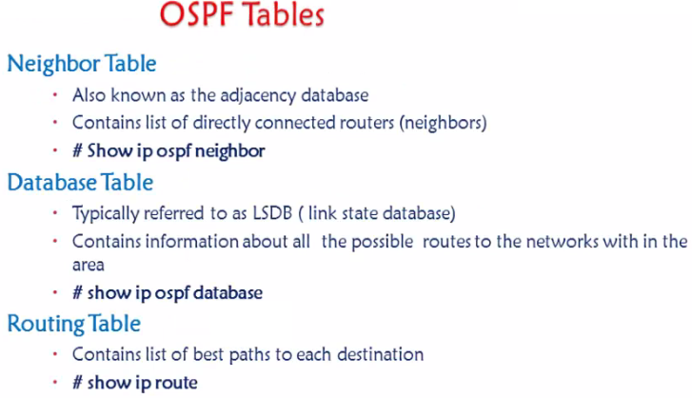

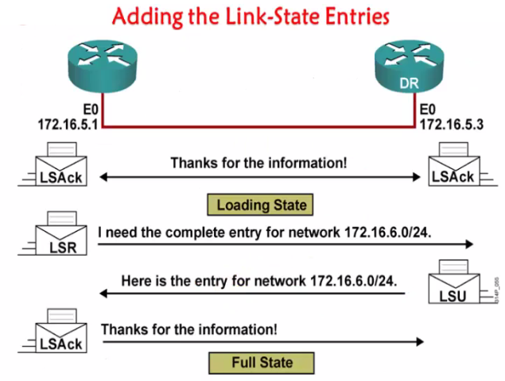

* The hello packet
* The Database Description **Packet** : ...
* The Link State Request **packet** : ...
* The Link State Update **packets**: ...
* The Link State Acknowledge **packets**

